



**Waterworks IT GIS**

**Google Earth BaseMap Project v 2.0**

**GETTING STARTED**

Here are some actions you can do to make Google Earth (GE) run a bit faster before adding the data. Once these steps are done and you “Save My Places”, your GE will open with these settings.

1. If you do not have Google Earth installed, please submit an IssueTrak requesting installation.
2. If you have Google Earth installed and experiencing difficulty with the application opening where the screen appears frozen, let it spin and do not touch anything within the GE window. It will spin anywhere from just a couple of minutes to maybe about 20 minutes. Once the Start Up is completed, right click on My Places 🡪 Delete Contents. Then File 🡪 Save 🡪 Save My Places. This clears all info so it will open up right away the next time and every time you open GE.
3. View 🡪 Uncheck 🡪 All items except for Toolbar, Sidebar, and Status Bar.
4. In the bottom left of the screen you will see the layers provided by Google Earth. Uncheck all unnecessary layers to free up memory. Keeping the 3D buildings layer unchecked while zoomed out will enhance performance speed greatly.
5. Add the Bookmarks file and the Waterworks Service Area Grid (WW_ServiceArea_40x40) located in [Google Earth](../../../../../Shared/Projects/GoogleEarth) projected folder by selecting the file in the Windows Explorer and then use the drag and drop method onto the GE globe. These two files will be added to the Temporary Places tab in the Table of Contents. You will want to right click on Temporary Places 🡪 Save To My Places. These will now be saved and appear every time you open GE.
6. Attempt to disable/uncheck layers while zoomed out for best performance.
7. For best results, have the Waterworks Basemap open to be able to reverse locate specific features in GE.
8. More tips can be found provided by GE by using the Help tab on the toolbar.

**HOW TO USE THE DATA**

Navigate to the folder labeled GoogleEarthData that contains an assortment of folders. In this folder, you will see folders that are labeled such as “Meter_Sections_KMZs”, “Hydrant_Section_KMZs”, etc…along with individual files such as “Access Gate”, “Airport”, etc.

The individual files are all of the files that contain less than 2,500 features and can be added to GE with the drag and drop method. All of the individual files from the BaseMap that have over 2,500 features have had to be broken up into sections using the 40x40 service area grid. Each folder contains its respective feature with a grid label identifier containing only those features within that grid.

**EXAMPLE – Working with the service grid**

You are interested in looking at all of the hydrants and meters in a neighborhood in Williamsburg. You would click the grid to get the grid number, in this example let’s say its grid 578.

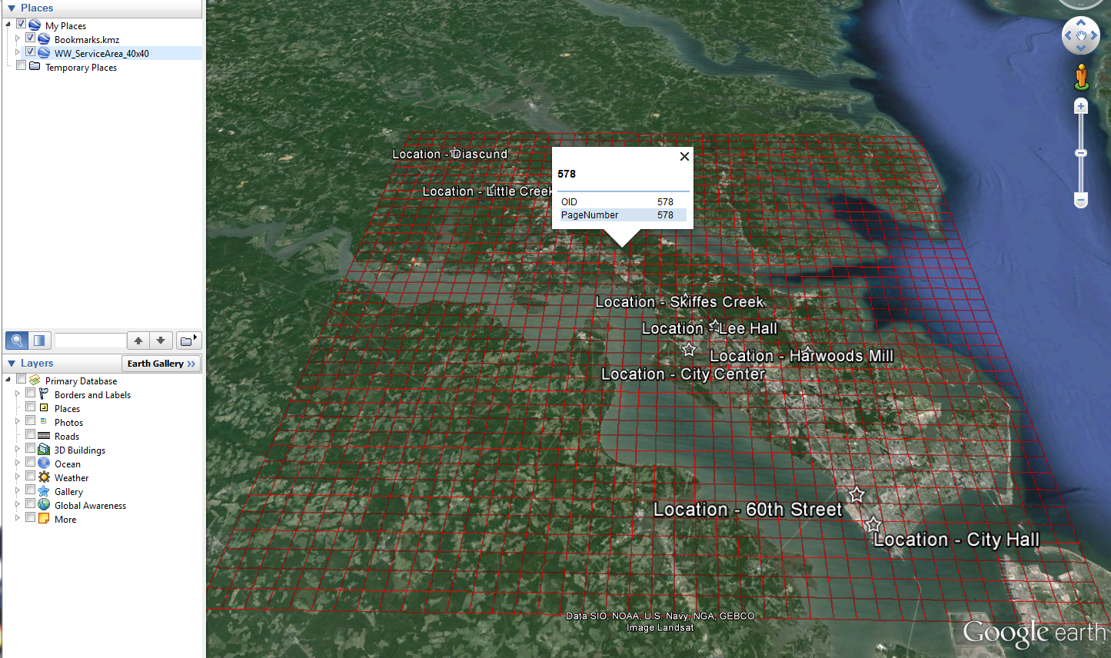

Go to the hydrant folder and locate the file for grid 578 (Hydrant_Grid_Layer_578) and drag and drop. Then go into the meter folder and find the meter file for grid 578 (Meter_Grid_Layer_578) and drag and drop.

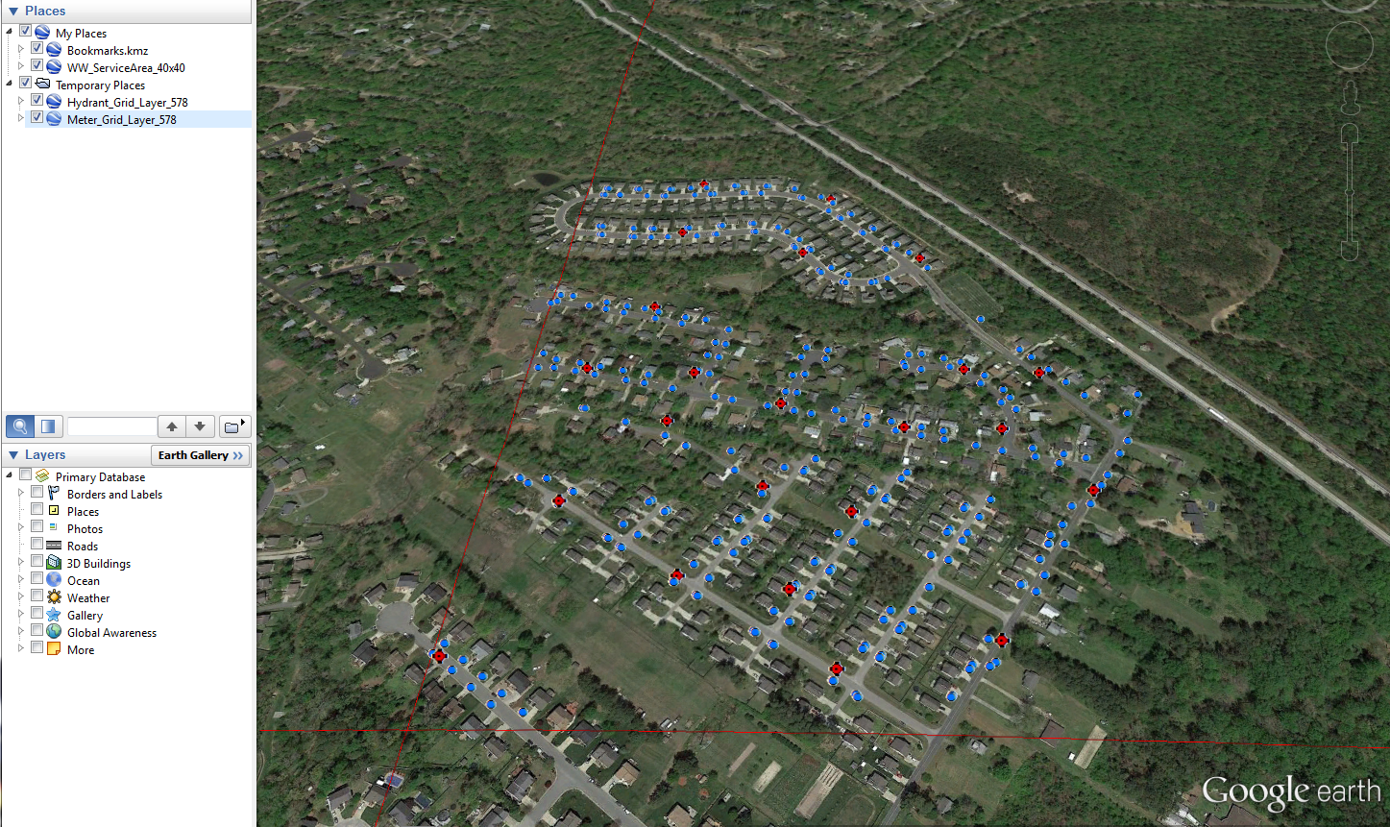

You will notice that the symbology of each of these layers is identical to the symbology that is used in the BaseMap. You will also notice that the files are more of a manageable size now so GE is able to provide an attribute table for every feature. All you have to do is single left click on any desired item and you will see a full attribute table.

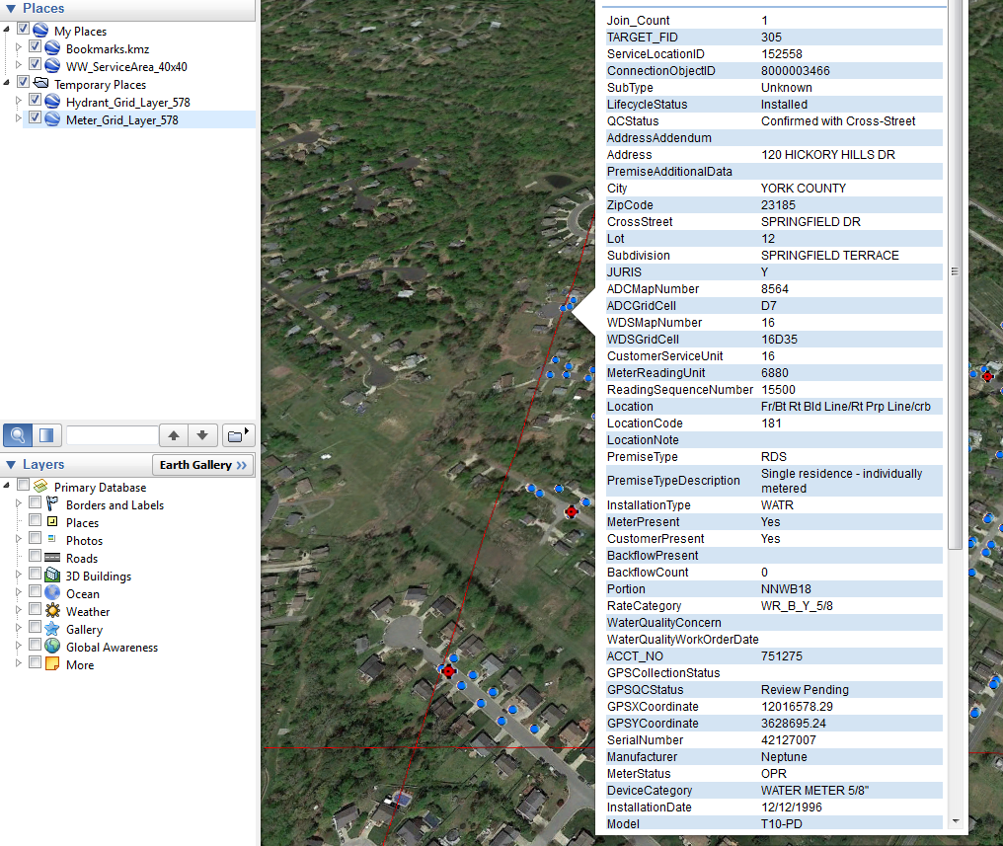

When you are done you can just close Google Earth, it will ask you if you would like to save and you can decide. Since all of the files that you brought in during the session are automatically placed in the Temporary Places folder, they will be deleted meaning that Google Earth will open right up the next time you want to use it if you choose the option to discard.

**HOW TO UPDATE THE DATA**

At the end of each week's normal GIS Maintenance, the individual GE files in the GoogleEarthData folder will be overwritten and updated to reflect any edits that have occurred since the previous update. To update your GE with the most up to date file, remove the outdated file from your GE interface and then use the same drag and drop method as before. The features that have been broken down and put into folders will be updated as needed.

**FINDING A SPECIFIC FEATURES**

Using the above method, it is possible to identify a specific feature by clicking on that feature and reading through the attribute table. So how would you work through locating a specific item out of the entire service area? To be able to reverse locate a specific feature, you will need to use the Waterworks Basemap. Once you have the basemap open using ArcMap, you can add the service grid to the shapefile.

* 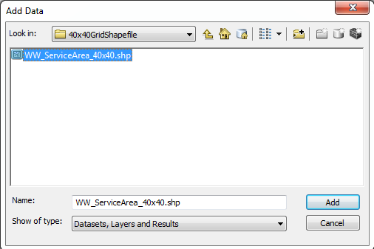Press the Add Data Button

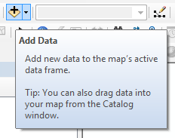

* Add the service area shapefile located at:

R:\Divisions\InfoTech\Shared\Projects\GoogleEarth\40x40GridShapefile\WW_ServiceArea_40x40.shp

* Once the shapefile has been added you can change the symbology and label the feature based on the “PageNumber” field.
  + Right click file name in the Table of Contents select Label Features
  + Double click file name, go to the Labels tab and choose “PageNumber” to ensure the grids are labeled correctly.

